Education with Destination
April 2020

Comprehensive Local Needs Assessment
Final Report
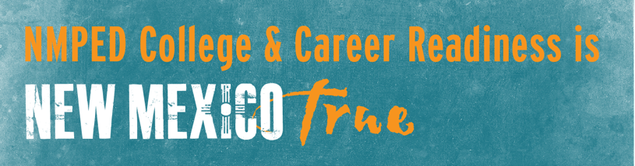

Table of Contents

Executive Summary 2
Optimizing the Next Generation of CTE 6
- The Need to Strengthen Education-Employer Connections
- The Shifting Workforce Landscape
- Connecting Labor Market Analysis and Economic Development
- Employers and Economic Developers Define Well-Qualified Talent
Comprehensive Local Needs Assessment 29
- Aligning Regions
- Data Collection
- CLNA Participants
Summary of Findings and Recommendations 36
- Focus Area One: The Vision for CTE
- Characteristics of Well-Qualified Talent
- Descriptions of Effective CTE Systems
- Focus Area 2: Industry Priorities
- Focus Area 3: Building Strong Partnerships
Appendix 52
- Appendix One: Population Changes
- Appendix Two: Educational Attainment
- Appendix Three: Deliverables
References 55

Our future competitiveness as a country in the increasingly interconnected global marketplace depends on our ability to build a workforce that supports current and projected workforce trends. While the requirements for jobs in constantly changing workplaces may vary, we know all good jobs will include some college, a college degree, or an industry certification. We must, therefore, sustain development of a well-prepared, properly-credentialed workforce that meets the needs of employers across all career fields. In recognition of the recent shifts occurring in the economy and the fluctuating demands of the workplace, the US Department of Education, along with Congress, recently passed an update to the Carl D. Perkins Vocational and Technical Education Act (Perkins V).

One of the most significant changes in Perkins V (officially titled, The Strengthening Career and Technical Education for the 21st Century Act) is the new requirement to conduct a Comprehensive Local Needs Assessment (CLNA) that is updated at least every two years for schools receiving federal funds for Career and Technical Education (CTE). New Mexico chose to leverage this continuous improvement opportunity to align educational more strategically to the needs of the workforce to ensure the delivery of high-demand, high-quality CTE, so that students are propelled through a connected, cohesive network on their way to lifelong career success.

The CLNA is the foundation for the development, improvement, approval, and funding of New Mexico’s CTE programs. The state’s educational, workforce, and economic development strategic vision and goals will be supported through a consortia-based organizational structure for CTE funding. Integrating a regional (rather than school site-based) needs assessment process has the potential to be a major driver of quality and equity in New Mexico. It provides a coordinated, in-depth look at the entire CTE system to identify areas where targeted investments can lead to increased alignment and opportunities for student success. It also provides an occasion to engage diverse stakeholders who are committed to the growth and improvement of New Mexico CTE.

With these policies in place, the New Mexico Public Education Department (NMPED) organized the Comprehensive Local Needs Assessment process to investigate the current and future workforce climate in the state. In partnership with The Bridge of Southern New Mexico and NS4ed, NMPED made extensive efforts to connect with employers across the state and gather information about their short-term and long-term needs. Three main focus areas were identified to guide research efforts and direct data collection and analysis. These focus areas, along with key findings and recommendations, are outlined below.

Executive Summary
Summary of Key Findings and Recommendations

- Focus Area 1: Characteristics of the Labor Market

  - New Mexicans expressed a very clear and consistent picture of the characteristics that would ensure the next generation of workforce talent is ready for success. Across ten identified regions, there was fairly consistent consensus along three categories: skills, attitudes, and workforce and life readiness. In general, the participants identified skills that were aligned to Employability and Hard Skills. Employability Skills were defined along a broad set of characteristics that are the essential skills, personal qualities and values that enable you to thrive in any workplace. By contrast, Hard Skills were seen as teachable and measurable abilities, such as math, English, writing, technology abilities, and the ability to continue to learn. The attitudes were seen as just as important, surfaced consistently, and described with specific terms like reliable, dependable, motivated, passionate, adaptable, culturally competent, resilient, and self-driven. It was stressed by the attendees that awareness of career opportunities in the regions was also critical in retaining their future workforce talent. A clear preference was demonstrated for industry-specific skills acquired through work-based learning and real-world experience. Degrees and certificates were reported to be most useful in the context of specific jobs with specialized skill sets.

  - It is recommended that NMPED evaluate and implement comprehensive programs that can assist in the development of employability skills and investigate ways to increase hard skill attainment.

Summary of Key Findings and Recommendations (continued)

- Focus Area 2: Description of CTE

  - By starting with a clear picture of the well-prepared, well-skilled talent needed in their region, each consortium was able to collectively describe the characteristics of the CTE system that could produce that kind of talent. Some regions recognized the potential and power of CTE to help forge a regional identity and pride – a force for stemming “brain drain” by connecting young people to the very best career opportunities in the region. Others honed-in on the idea of CTE as a “community” requiring strong collaboration to foster a sense of belonging across stakeholders: students, teachers, employers, and others. One region called it “a public priority.”

  - There was a clarion call statewide for closer alignment to the needs of business and industry, agility in responding to employer needs, and connecting work-based learning for real world experiences for students, with mentorship, internships, apprenticeships, and externships being specifically discussed. Robust CTE systems would be valued by employers if they were relevant and responsive to employers’ needs. Then, educators and students could benefit from active partnerships with business…far beyond the traditional “advisory committee” approach.

Summary of Key Findings and Recommendations (continued)

- Focus Area 3: High Quality Partnerships

  - The stakeholder meetings allowed each consortium to bring together a diverse group of contributors. The model, defined in Perkins V, asked for regions to prioritize CTE funding decisions through shared decisions and shared ownership of implementation. Because of the sense of community and consensus cultivated in each meeting, commitments to continue the conversations and work toward goals extended beyond the education providers to include employers, local workforce boards, economic developers, and even non-profits. The alignment of agreed-upon priority industries with the sector strategies of local workforce boards also maximized the impact of federal investments toward a comprehensive approach to talent development for each region’s target industries.

  - It is recommended that NMPED foster and encourage each regional consortium to produce quarterly updates and quarterly analysis of goals achieved. By establishing a consistent model, the development of these community collaborations could continue to mature and develop a quicker, more efficient response to the needs of the communities that they serve.

The challenge in preparing students for careers is that employers, educators, and students tend to operate in separate spheres, with minimal intersection. Educators struggle to fully understand the needs of employers and vice versa. Caught in the middle are students who lack direction for their educational goals and have limited awareness of available career options and the skills needed to succeed in these careers. To pave the way for employment success among students, create pools of well-qualified talent for employers, and increase the economic prosperity of communities, disconnects between education and employment must be overcome.

Optimizing the Next Generation of CTE
New Mexico’s long-term wellbeing rides on the economic empowerment of its people. Overcoming these disconnects and aligning Federal and State investments across the workforce development continuum has the potential to end cycles of poverty and unleash a new generation of highly qualified future employees and entrepreneurs to propel the state forward.

The Need to Strengthen Education-Employer Connections

K-12 school systems invest tremendous efforts in prepare students for postsecondary success – formerly the best pathway to the middle class or higher. Despite these well-intentioned efforts, recent surveys and reports indicate that current approaches to education are misaligned with today’s workforce demands. This is evidenced in two main factors: (1) the middle- and technical-skills gaps growing ever wider across the nation and (2) the shifting value of degrees and certificates in the 21st Century workforce. These two factors suggest that many students are exiting educational institutions with mismatched skills and degree aspirations that may not adequately support employment success.

Identifying and Closing the Skills Gap
A growing number of studies have identified a disconnect between jobs available and a workforce pool that is career ready—between skills required and skilled workers available to businesses (Carnevale, Smith, & Strohl, 2010). A primary condition which contributes to this disconnect is that applicants do not have required skills. A McKinsey Group survey of 2,000 businesses found 40% of employers who were recruiting for their companies had positions open at least six months because they could not find suitable candidates with the required skills: Close to half of all college graduates applying for open jobs did not have the necessary applied skills to be hired; and 39% of high-school graduates wanting to go directly to work were unprepared for entry-level jobs (Society for Human Resources Management, 2008). As a result, jobs across every industry—from entry level to upper technical and management echelons requiring one or more higher education degrees—are open (Memmot, 2011). A national broadcast (CNBC, 2011) reported on the inability of major companies and small businesses to match skills to positions, concluding that structural gaps in employment in our country occur because we are not adequately developing and sustaining a workforce with the skills needed and in demand to compete in the 21st Century.
A 2013 survey of 500 senior executives in a variety of industries found 92% believed there is a serious lack of required workforce skills for posted jobs and, as a result, nearly 50% reported they are having trouble filling needed jobs. Survey participants cited technical (22%), leadership (14%), and computer skills (12%) as lacking from among needed skills. Other lacking skills were those that contribute to successful employees, including the ability to work as part of a team and independent problem solving (Adecco Group, 2013).
A Georgetown University study (Carnevale, Smith, & Strohl, 2013) suggests this problem across all industries is further compounded as Baby Boomers retire and the workforce shrinks, so that by 2020, we could see 5,000,000 positions go unfilled. This lack of available job-ready employees poses problems across the board for employers. For example, lost revenue and productivity were reported as high as $23,000 per unfilled position and up to an 11% loss in annual earnings (Accenture Manufacturing Institute, 2014).
A 2017 report from the National Academies of Sciences, Engineering, and Medicine (Frueh, 2017) sought to further profile the supply of and demand for workers and found that skilled technical worker (i.e., for jobs that require a high level of knowledge in a technical field for entry, but not a bachelor’s degree) are a growing area of demand for employers. This category of workers is needed in most occupational groups, from health care to construction to manufacturing. Examples include medical laboratory technicians, installation/repair technicians, and computer support specialists. The report concluded with the suggestion that policymakers, employers, and educational institutions work together to strengthen all areas of our workforce (Frueh, 2017).
Our country’s competitiveness is being hurt by a skills shortage (Cohn, 2017). The United States is experiencing imbalances in worker supply and demand in key occupations, industry sectors, and locations. Gaps are particularly evident in health care and manufacturing, although shortages in the worker supply are reported in almost every industry (Frueh, 2017). To those who recognize the gap, it has become a blame game as employers point fingers at education, educators point back at employers, and far too many graduates are left in the middle, jobless and unprepared for jobs in demand.
Across all venues and these inclusive industries, employers talk about the “skills gap” between the jobs they need to fill at all levels and the workers available for these jobs. For corporate leaders, the most crucial issue influencing corporate decisions about where to locate or expand operations is the ability to recruit and retain the best workforce (Cohn, 2017). This has serious implications for regional and local economies.
It defies business theory that as salaries and other benefits go up for certain highly skilled jobs, workers do not flood the education and training programs that would qualify them for these jobs. As pointed out in a study by the Organization for Economic Cooperation and Development, students’ awareness of job and career opportunities is severely limiting their ability to engage in the emerging economy. “What we know about the future of work doesn’t make its way into classrooms and experiences of young people,” said Andreas Schleicher, OECD director for education and skills and co-author of the study. We clearly need to develop strategies that will enable us to close both the awareness and kills gaps and, thereby, assure a higher level of workforce productivity (Templeton, 2018).
The consequences of not closing the gaps are clear, in the form of social and economic distress that comes about when too many young people are not aware of or prepared for robust and growing job opportunities and too many businesses are frustrated by the lack of a prepared workforce in their regions.
The Changing Value of Degrees
In addition to the skills gap, we are seeing changes in the value of degrees and certificates. In the past, a bachelor’s degree carried a relatively high guarantee of employment success and corresponding earning power. Other degrees and certificates were downplayed in value in comparison to a bachelor’s degree. Today, economic changes and the increasing cost of college is making this picture more complex. A recent survey reported in Forbes estimated 34% of college graduates are underemployed (Cooper, 2017). Similarly, Weissmann (2012) reported that nearly 54% of bachelor’s degree holders age 25 and under were either unemployed or underemployed (i.e., working in jobs that do not require a degree). Such findings bring the return on investment for bachelor’s degrees into question.
While bachelor’s degrees still lead to a majority of good jobs, it is becoming increasingly apparent that student’s choice of college major is critical (Carnevale, Fasules, Huie, & Troutman, 2017). Simply having a bachelor’s degree is no longer the automatic fast track to better jobs or higher wages that it may have been in the past. Rather, majors selected in high-demand fields are most likely to promote employment success. Choosing the wrong major can place students in the position of investing large amounts of time and money into a degree that has little value in the job market, ultimately leading to employment failure.
The good news is that other educational pathways are rising in opportunity and providing alternatives for students. Specifically, there is an increasing demand for middle-skills credentials, such as associate degrees, trade certificates, licenses, and other postsecondary certifications. Nationally, middle-skill jobs account for about 53% of good jobs. In New Mexico, 52% of good jobs are middle-skilled jobs. Furthermore, good jobs at this education level are rising faster than jobs at the high school level (Carnevale, Strohl, Ridley, & Gulish, 2018). Such trends point to the middle-skills education pathway as being a viable alternative to four-year degrees. Indeed, there are several middle-skills jobs that have the potential to pay more than jobs requiring a bachelor’s degree, especially in STEM-related fields (Carnevale & Cheah, 2018; Carnevale, Strohl, Cheah, & Ridley, 2017).
The rising demand for middle-skills credentials is contrasted with the declining opportunities for individuals with a high school diploma (Carnevale et al., 2018). The low-skill jobs that paid individuals in the past are being rapidly replaced with new technology that can automate simple and repetitive tasks. Because these low-skill tasks can be so easily replaced with technology, employers are expecting more from their workers and demanding skills that compliment technology. Thus, there is a push for skilled labor that can support the rising task demands of today’s workplace.
The emerging picture here is that the common postsecondary targets that schools prepare students to achieve may not align well with current workforce demands. The traditional approach of preparing students for entry into a four-year institution or immediate entry into a career with a high school diploma can be dangerously restrictive. This limited dichotomy has the potential to leave students underprepared for today’s jobs and unaware of alternative pathways to employment success. To ensure students are provided the best opportunities to access viable careers in multiple fields, educational institutions will need to connect with local industries to identify appropriate education targets. Once identified, education pathways can be established to help students achieve employment success in their local communities.

This Shifting Workforce Landscape

To understand why the skills gap is happening and why degree values are changing, we need to look at some of the dramatic shifts occurring in our workforce landscape.
One of the major driving factors behind the shifting nature of work is the emergence of the Fourth Industrial Revolution or “Industry 4.0.” This revolution is marked by rapid advances in automation, the emergence of artificial intelligence, and the fusion of technology with almost every aspect of daily living. Unlike previous revolutions that progressed over many years, this revolution will be rapid and pervasive. As a result, there is an unprecedented demand for skilled workers with knowledge of both the use and maintenance of new technology (World Economic Forum, 2018).
Along with rapid shifts in technology, there are also several social, economic, and environmental factors affecting jobs. For one, the number of elderly individuals is increasing in the United States, creating a rising demand for skilled healthcare professionals. Furthermore, the economy is becoming more globalized and companies are sending low-skill jobs overseas to capitalize on lower labor costs. As for environmental factors, renewable power resources are becoming more important, resulting in a growing need for individuals who can develop and work with green energy solutions.
All of these changes are having dramatic effects on the future of work. Technology demands in the workplace are increasing and job opportunities are moving toward more skilled professions. As a result, the skills that supported generations of the past will need to shift to align with the demands of today’s workplace. Digital skills are becoming increasingly valued, as are STEM-related skills (Crowe, 2019; Manyika et al., 2017). In addition, individuals trained in job-specific skills aligned with high-demand professions, such as health care, will be highly sought after (Carnevale et al., 2018; Shearer & Shah, 2018). Of most critical need are employability skills, or soft skills, that complement the use of technology. These skills, which include critical thinking, problem solving, teamwork, and other related abilities, are currently within the top reported skill needs among employers (Bloomberg Next, 2018; Udemy, 2018; US Chamber of Commerce Foundation, 2017).
Because these changes are occurring at such a rapid pace, they are contributing to large gaps between employer needs and workforce supply. There simply has not been sufficient time to gain awareness of workforce needs and prepare individuals for these new demands. Consequently, individuals are entering the job market without required skills and credentials, especially middle-skills training, that support successful job performance and provide entry into rising professions.

The Role of Education
Within the field of education, a new force is emerging with a strong emphasis on preparing students for the changing demands of today’s careers. A primary goal of recent policymaking activities, both at national and state levels, has been to improve alignment between education practices and workforce needs. As a result, significant efforts have been made to implement career-ready standards and scale up career pathways that prepare students for high-value jobs. In addition, there has been considerable rethinking and reform of career and technical education (CTE) programs to ensure these programs are more in tune with the rapidly shifting needs of employers.
Educational institutions will need to continue to evolve to help students meet the demands of the changing economy and careers. Connecting with industry and staying abreast of shifting demands is a critical part of this process. When there is a strong point of connection between education and employers, valuable information can be exchanged about the skills employers need and the services education provides. Information gained from employers can inform education practices and help ensure students are ready for work. When education is disconnected from industry, there is the risk of students entering the workforce with outdated or mismatched skills. Maintaining contact with employers and developing programs that address the development of valued workplace skills is critical to students’ future success.
Perkins V Goals and Priorities
​The Strengthening Career and Technical Education for the 21st Century Act (Perkins V) was signed into law by President Trump on July 31, 2018. This bipartisan measure reauthorized the Carl D. Perkins Career and Technical Education Act of 2006 (Perkins IV) and continued Congress’ commitment in providing nearly $1.3 billion annually for career and technical education (CTE) programs for our nation’s youth and adults (Estes, 2018).
Perkins V represents an important opportunity to expand opportunities for every student to explore, choose, and follow career and technical education programs of study and career pathways to earn credentials of value. Perkins V is largely based on the structure and content of current law but makes some key changes that will impact the implementation of CTE programs and administrative processes around the country (Advance CTE, 2018).

Perkins V Purpose
- To develop more fully the academic knowledge and technical and employability skills of secondary education students and postsecondary education students who elect to enroll in career and technical education programs and programs of study by…”
- Building on the efforts of states and localities
- Linking secondary and postsecondary education programs
- Increasing state and local flexibility
- Conducting and disseminating national research
- Promoting professional development
- Supporting partnerships
- Providing lifetime learning opportunities
- Increasing employment opportunities for chronically unemployed or underemployed populations

Perkins V Notable Changes
- Emphasis on Data-Informed Decision-Making
  - Local Needs Assessment –included in the local application and used to inform local funding decisions
- Reduction of the Role of the U.S. Secretary of Education
- Increase in Stakeholder Involvement
  - Public Comment and Review Process –state performance targets must be developed in consultation with stakeholders with an opportunity for the public to submit comments
  - Local Stakeholder Involvement –stakeholders should be continuously consulted on topics related to the need’s assessment, workforce needs, work-based learning, and coordination of funding
- Revision of Accountability Indicators
  - Consolidation of Non-Traditional Measures –two reduced to one
  - Technical Skill Attainment Measure –replaced with “Program Quality”
- Enhanced Efforts to Serve Special Populations
- Encouragement of Innovation
  - New Priorities for Reserve Funds –need to be targeted toward fostering innovation or supporting programs aligned with high-skill, high-wage, or in-demand occupations
- Inclusion of “Middle Grades”

Perkins V State Allocations
- States receive a “Foundational Grant” that is equal to the amount received in 2018
- Remaining funds are allotted to states by a formula based on population aged 15-65 and per-capita income
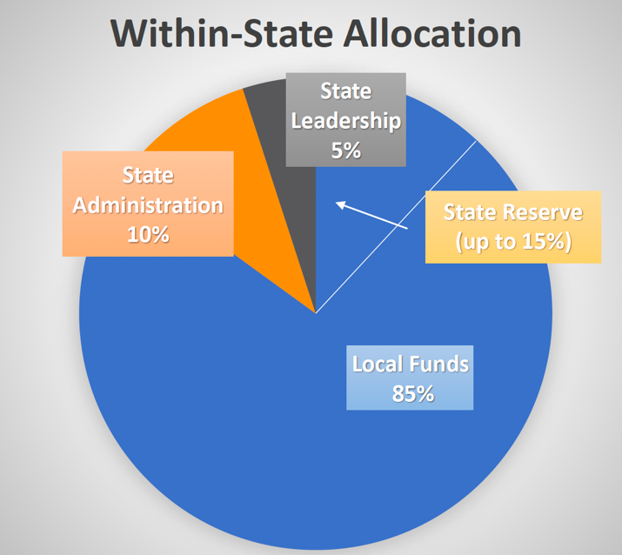
      - Within each state, funds are divided to meet state and local needs
- States can reserve up to 15% of local funds for alternative distribution to local programs in…
  - Rural areas
  - Areas with high percentages/numbers of CTE students
  - Areas with performance gaps between groups
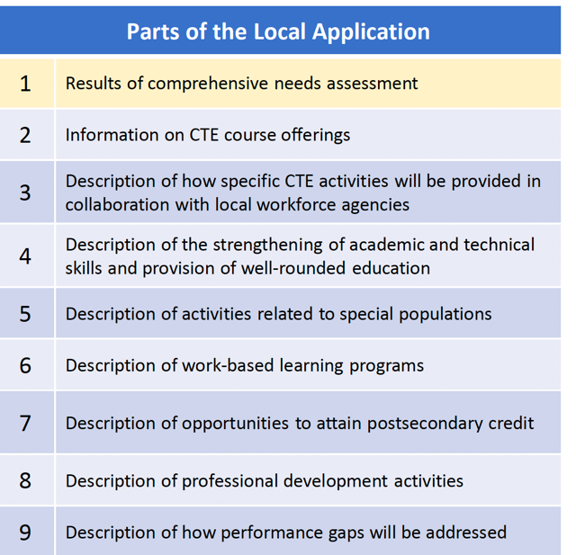
Perkins V Process and Responsibilities
A fair amount of attention and discussion has been focused on the Local Application. This is primarily due to the addition of the Local Needs Assessment. States will often have specific procedures for completion of the local application.

Often viewed as the single biggest change between Perkins IV and V. It is meant to serve as the foundation of the local application and used to determine future spending on career and technical education. The Primary goal is to promote better alignment of CTE programs with state, regional, and local economic needs

WIOA Summary
WIOA reauthorized the Workforce Investment Act of 1998 (WIA) and was passed by Congress and signed into law in 2014 to be authorized through 2019.
Purpose: WIOA supports workforce development activities and funds job training programs for displaced adult and youth workers. The legislation modernized the nation’s workforce development system and streamlined existing employment and workforce-related education and training systems via unified planning and delivery, common measurements for program performance, and more uniform data collection and usage among many other improvements to WIA.
Connection to Career Technical Education (CTE): WIOA emphasizes greater coordination between workforce development and CTE through aligned definitions, the requirement that postsecondary CTE be a local infrastructure partner, the option to do a combined state plan that meets the planning requirements for WIOA’s core programs and at least one other federal program, and other provisions. (Advance CTE, 2018).

Connecting Labor Market Analysis
and Economic Development

The innovative and unprecedented approach the New Mexico Public Education Department took to this project integrated industry needs, economic development objectives, and macroeconomic analysis into the Comprehensive Local Needs Assessment (CLNA) process required by the Strengthening Career and Technical Education for the 21st Century Act. A professional analysis of the labor markets in each of the state’s ten CTE Regions formed a baseline for a decision-making process that eventually included community members and leaders from business, economic development, education, and local government in each region.
These CLNA meetings reviewed the labor market analyses, crafted a vision for CTE in their region, established skills profiles for the region’s ideal workforce, and prioritized industry sectors for targeted investments. In doing so, their work established guidelines for districts who intend, either independently or in partnership with others, to submit proposals for Perkins funding.
The conceptual underpinnings of this effort were summed up in a statement from a conference attendee: “We are going to make CTE accountable to the community.”
Governor’s Priorities
As part of her vision for a 21st Century New Mexico economy, Governor Michelle Lujan Grisham identified eight priority industry sectors that she sees as the foundation of New Mexico’s economic future:
- Aerospace
- Intelligent Manufacturing
- Bioscience and Health
- Tourism and Outdoor Industries
- Cybersecurity
- Sustainable and Green Industries
- Digital Media and Film
- Sustainable Agriculture

There is an opportunity for the state’s education systems to leverage its CTE programming as a tool for economic development and business attraction. One objective of this initiative was to better align CTE strategy with the economic objectives of the state.
The Governor’s economic development priorities were communicated in each of the 10 regional meetings as factors to be considered as each region prioritized its industries and established a vision for Career and Technical Education.
Population Trends
The labor market analyses provided a broad-based perspective on each region by leveraging multiple public data sets and aligning observations on trends in each region’s demographics, labor market, and education data. During analysis of the demographics data, a number of trends emerged:
Total Population
- Twenty counties across New Mexico have experience negative population change since 2010, and twelve showed growth. Two were unchanged.
- While the population of the state as a whole expanded during this time frame, the bulk of that growth was in Bernalillo and Sandoval Counties, which together accounted for growth of more than 27,000 people.
A Graying Population
- The population in almost all the regions is aging. The percentage of the population that is under 20 years of age declined in nine of the ten regions, while the 65+ population grew by larger numbers than any other age band in every region.
For a summary of the population change data, see Appendix One.
Educational Attainment
We leveraged data from the United States Census Bureau American Community Survey to measure the educational attainment levels of each CTE Region and compared those to the state and national norms. At the time of the analysis, the percentage of people 25 years and older who have attained a bachelor’s degree or higher in the United States was 30.9%. It has since moved to 32.6%. Across New Mexico, that number is 27.7%. That metric tops 30% in only two of the CTE regions, Region D (33%) and Region E (30%). Region B comes in at 29%. The lowest percentages are found in Region A (13%), Region K (15%) and Region C (19%).
For a summary of educational attainment levels, see Appendix Two.
Labor Market Trends
Largest Industries
In each analysis, we inventoried the largest industries in the region per the total number of people employed. In seven of the ten regions, the three largest industries in the most general categories, were identical:
- Government
- Health Care
- Retail Trade
The exceptions were Regions B and C, where the Accommodation and Food Services industry ranked third, and Region K, in which the Mining, Quarrying and Oil and Gas Extraction industry is the largest, followed by Government and Retail Trade.
The CLNA attendees were asked to prioritize industries in their regions using their own judgement and first-hand perspective, but against the backdrop of these empirical data.
Largest Location Quotients
The most technical data point in each analysis was an Employment Location Quotient (LQ). This is a value in which the concentration of a region’s employment in a particular industry is indexed against the national norm. For example, if the percentage of a region’s workforce that is employed in the Aerospace Manufacturing sector were identical to the national average, that industry would return an LQ of 1.0. If the region’s workforce were employed in that industry at a rate double the national average, that would return an LQ of 2.0.
We estimated Location Quotients for detailed industries in each region, using that value to highlight industries that are part of the unique fabric of the communities, regardless of total employment. This was a critical exercise, as the perspective afforded by looking at the industries uniquely important to each region yielded informed and robust conversation and quelled concerns that simply looking at total employment didn’t allow for enough local character.
We calculated and inventoried the Location Quotient for each detailed industry in each region and highlighted the largest LQ’s. Each region has a different industry with the largest LQ. This speaks to the uniqueness of the communities across New Mexico and the appropriateness of this approach which allowed for consideration of the unique economic realities of each.

Table X: Industries by Location Quotient:
Region | Largest Location Quotient | #2 Location Quotient | #3 Location Quotient
A | Natural Gas Extraction | Coal Mining | Support Activities for Mining
B | R&D-Physical/Engineering/Life Sciences | Audio/Visual Equip Manufacturing | Lighting Fixture Manufacturing
C | Education-Local Gov | Services for the Elderly and Disabled | Hotels
D | Jewelry and Silverware Manufacturing | Other Outpatient Care Centers | Direct Life, Health and Medical Insurance Carriers
E | Hospitals | Research & Development – Physical/Engineering/Life Sciences | Telephone Call Centers
G | Copper, Lead, Nickel and Zinc Mining | Animal Production | Water/Sewer Line Construction
H | Facilities Support Services | Military | Federal Government, Civilian
I | Animal Production | Dairy Manufacturing | Specialized Long-Distance Freight
J | Fruit and Vegetable Canning, Pickling and Drying | Seasoning and Dressing Manufacturing | Wood Products Manufacturing
K | Nonmetallic Mineral Mining and Quarrying | Crude Petroleum Extraction | Pipeline Transportation

Workforce Equilibrium
Successfully building, attracting and sustaining employers from these priority sectors requires a robust, responsive, and aligned system of career and technical education. High-value employers understand the critical importance of CTE within their estimations of available talent supply. Site selectors report that among the range of considerations that go into decisions about growth and relocation decisions, the quality of the local workforce is a top priority.
Each region’s labor market analysis inventoried the most popular college majors in each region and aligned the number of graduates from those programs with the projected number of annual openings in related occupations. The resulting “workforce equilibrium” value was used to estimate “skills gaps” for high-priority occupations.
In many regions, programs like Social Work, English and Psychology had significantly more graduates than regional openings in related occupations. Programs that tended to show a negative Workforce Equilibrium Value included Business Administration, Computer and Information Sciences, Registered Nursing, and various education programs.

Strategy
Recommendations
In each analysis, five areas of the labor market were recommended on the basis of the labor market data as starting points for the CLNA conversations to establish priorities for their regions. The recommendations included:
- Health Care
- Business Management and Financial Operations
- Industrial Production Technology
- Skilled Construction Trades
- 21st Century Transportation
- STEM
- Education
- Engineering Technologies
- Information Technology
- Mining and Natural Resources
- Public Administration
- Installation, Maintenance and Repair
Each region’s recommendations and industry sector targets are aligned and mapped in Focus Area 2 which follows.
Opportunities for Increasing Alignment
Workforce Development is a multi-million-dollar investment New Mexico makes in its people every year. The recently completed 2020-2023 Combined State Plan by the Department of Workforce Solutions harnesses and directs more than $70 million in federal investment toward the Governor’s prioritized industries through a web of programs that haven’t always worked in connection and coordination with one another:
- Workforce Innovation and Opportunity Act (WIOA)
- Wagner-Peyser Act
- Division of Vocational Rehabilitation (DVR)
- Jobs for Veterans State Grants Program
- Senior Community Service Employment Program
- Temporary Assistance for Needy Families (TANF)
- Trade Adjustment Assistance for Workers Program
Perkins V funding, while also a federal investment, is not included in the Combined Plan at this time. However, regional consortia meetings, by and large, prioritized industry sectors that were well aligned to the Sector Strategies being advanced by three of the four local workforce boards that oversee WIOA funds. Collectively, New Mexico receives $25 million in WIOA funding, which is then distributed across the state through the local boards. Aligning this investment with Perkins toward priority industry sectors will increase the ability of consortia regions and local workforce boards to comprehensively invest in holistic talent pipelines for in-school children and youth, Opportunity Youth (those 16-24 not in school nor working), and low-skilled and low-income adults. Perkins investments in community college programs will render rewards for WIOA-funded students pursuing education aligned to in-demand jobs in priority sectors.

In a separate, but connected effort, the Adult Education providers are partnering with Jobs for the Future on “a comprehensive landscape analysis and a collaborative strategic planning process with and for the New Mexico Higher Education Department (NMHED) and other state agencies and organizations that will result in concrete, actionable recommendations for how to build a more inclusive and innovative talent pipeline and workforce development system focused on the state’s top ten in-demand workforce sectors.” According to the proposal, the project will render:
- A landscape analysis report will provide detailed information about the in-demand industry sectors job market in New Mexico; the current state of New Mexico’s educational, training, and nonprofit capacity to meet the demand for a talent pipeline; and the current gaps and needs that must be addressed to build additional capacity.
- A comprehensive strategic roadmap for developing state and regional capacity to better meet the needs of employers and to strengthen and diversify the tech talent pipeline

It is likely that the Labor Market Analysis of each region conducted by NS4ed will inform their work and support further alignment with both Adult Education programs and Higher Education institutions in the state. The Department of Workforce Solutions is keeping an eye on this project to determine its role in picking up implementation of the work once the plan is complete.

Another new asset in talent development in the state is the recently approved New Mexico Opportunity Scholarship that supports Pell-eligible college students in completing two-year degrees. The Governor’s expressed intention to support low-skilled adults who want to go back to school to “upskill” for higher paying jobs provides a platform for alignment of workforce investments in target industry sectors. Perkins-funded programs will be of benefit to Opportunity Scholarship recipients.

New Mexico’s Dual Credit program also has an important role to play in accelerating the impact of CTE programs statewide. Career certifications and two-year degrees aligned to employer needs provide an immediate boost to the earning power of high school graduates. With the majority of college students also working while pursuing their education, increasing their earning power also increases their ability to graduate, regardless of how far they go in their post-secondary careers. Early College High Schools, which provide focused CTE pathways to career certifications and two-year degrees, provide the foundation for scaling models to increased utilization and alignment of dual credit courses within CTE pathways for students in traditional high schools. Current funding shortfalls for Higher Education partners could be buoyed by prioritizing CTE courses for students who wish to pursue dual credit courses.

Employers and Economic Developers
Define Well-Skilled Talent

Perkins V is distinctly different from its predecessors in that the voice of local business, industry, and economic development is intended to lead local decision-making efforts. The recruitment of Consortia Leads from regional chambers of commerce and economic development entities placed those voices at the forefront of the regional Comprehensive Local Needs Assessment (CLNA) meetings. They were able to leverage their relationships with key employers in the region to encourage participation in CLNA meetings and decision making.
The CLNA meetings enhanced existing relationships between CTE educators and employers, as well as forging new ones. The perfect example of this is in healthcare, which the majority of regions selected as one of their target industries. Success will require a stronger partnership with healthcare employers in order to structurally expand the capacity to produce qualified workers through the educational pipeline. Many healthcare programs require on-site clinical experiences. Higher education institutions face shortages of qualified faculty due to the opportunity for potential instructors to earn more in the field than in the classroom. Solving these and other complex problems will require hand-in-hand partnership between education and industry.
To further enhance business’ ability to inform the conversation, two surveys (one long, one short) were deployed for employers who couldn’t attend. Economic developers were also invited to weigh in through a survey of their own. In total, 58 employers who employ 8,752 employees in 27 counties participated in the employer survey. Primary places of business are indicated in the chart below.

EMPLOYERS SURVEY RESULTS
Employers were asked to describe the most jobs in their companies, and they fell into the following categories:

Workforce is historically THE key issue for employers across the nation, not just in New Mexico. Employers need employees with the right skills, the right knowledge, right now. Participating employers did indicate the need is great, which means CTE has a vital role to play in closing the gaps. When well aligned to employers’ needs, it becomes a far more powerful partner in the talent development pipeline.
The chart below shows the critical reasons why employers struggle to find talent. Conceivably, well-aligned CTE programs can help solve four of the 11 identified challenges. Those with work-based learning components can create win-win opportunities for employers and students. Employers value work experience, yet students frequently have a difficult time getting real-world experience offered by internships, apprenticeships, and summer and part-time jobs.
This presents an opportunity to meaningfully engage employers in CTE pathways by integrating these experiences in order to directly respond to the needs of business and industry.

Employers who participated in the survey also indicated the minimum educational requirements needed for most of their jobs. Their answers show opportunity across the educational spectrum. High school ranked highest, but post-secondary credentials, as a group, actually come in second place at 48% collectively. Interestingly, the high percentage that reported no requirement reflects the finding that skills are valued over education credentials. Employers in the survey also do not seem to either be aware of or value newer forms of credentialing like micro-credentials, digital badges, or WorkKeys scores.

Based on the survey, it does seem there is some awareness among employers of educational programs that support the development of talent. There is an opportunity to increase the quantity and quality of these partnerships in order to boost actual connections between employers and students.

Perhaps the most telling part of the survey involves the assessment of the specific skills gaps between what employers need and what potential candidates seem qualified to do. Information from the survey can be used in two ways:
- Defining the specific skills that must be built into potential talent due to the high demand employers have for those skills
- Making a powerful case for closer integration between CTE and core instruction
Following are the breakdowns of employer response in the following categories:
- Math
- English Language Arts
- Employability or “Soft” Skills
- Technology
- Digital Literacy

ECONOMIC DEVELOPERS SURVEY FINDINGS
Surveys were also completed by 12 economic developers representing 18 counties. As a group, their target industries currently employ 705, but in their recruitment efforts, they seek to triple those numbers in order to reach 1,405 new employees.

In large part, their economic development targets show alignment with Gov. Michelle Lujan-Grisham’s targeted industries for a diversified economy.

The importance of CTE pathways in preparation of middle and high-skilled future talent is also clear, as medium and considerable preparation are indicated as the primary need for the jobs in these industries.

Another revealing finding in the research of economic developers is the connection between perception of skills and knowledge relative to diplomas and degrees. According to the survey, the higher the educational credential, the more likely the perception that candidates would have foundational core skills needed by employers. The following three graphs track the changing perceptions of skill readiness based on educational levels.

In light of all that employers and economic developers have indicated in their surveys, there is a clear need/opportunity to elevate awareness of the quality of CTE graduates at both high school and college for employers looking to secure the highest quality talent. As New Mexico maps out the Next Generation of CTE for the state, a statewide communications campaign and local outreach efforts will simultaneously build demand for CTE courses among students and parents and for CTE graduates among employers.

Comprehensive Local Needs Assessment

Goins to do this section

The CLNA participants and process focused on stakeholder involvement and emphasized a comprehensive voice for each region. To begin the CLNA process, an initial webinar was offer for participants to understand the goals and the program structure. The invitations to attend the webinars were sent out by PED and The Bridge of Southern New Mexico. In total seven webinars were offered with an average of 50 participants per webinar for a total of 350 participants, the dates were as follows:

- January 6, 2020 (Consortia Leads only)
- January 22, 2020 (Educators only morning session and an afternoon session)
- January 23, 2020 (Educators only morning session and an afternoon session)
- February 7, 2020 (Educators only morning session and an afternoon session)

Regional Consortia Leads included:
- Region A – Gallup Economic Development
- Region B – Regional Development Corporation
- Region C – Union County Economic Development Corporation/NEEDO
- Region D – Association of Commerce and Industry
- Region E – Sandoval Economic Development Alliance/Rio Rancho Chamber of Commerce
- Region G – Silver City Chamber of Commerce/Deming Chamber of Commerce/Mid-Rio Economic Development
- Region H – Ruidoso Chamber of Commerce
- Region I – Clovis Industrial Development Corporation
- Region J – Mesilla Valley Economic Development Alliance
- Region K – Carlsbad Industrial Action, Inc./Lea County Economic Development Corporation/Hobbs Chamber of Commerce/Lovington Chamber of Commerce/Roswell Chamber of Commerce

During the educator webinars, the Consortia Leads for each region were identified, as well as targeted meeting dates for the CLNA meetings. Next steps in the process were laid out, and a technical resource center to support the work was shared with all participants.

The CLNA Goals were presented as follows:
- Recruit business and economic development entities to serve as Consortia Leads
- Conduct Regional Consortia Meetings
- Convened by Consortia Leads
- Share findings with consortia members
- Determine agreed upon industry sectors/needs
- Designation of “workgroup” members to carry out the consortia’s priorities

The Role for each consortia lead was established as follows:
- Provide guidance to The Bridge on relevant community partners who should be a part of the Comprehensive Local Needs Assessment (CLNA)
- Invite businesses and economic developers to:
  - Participate in an on-line survey
  - Attend the CLNA meeting
- Secure location CLNA meeting
- Provide staffing assistance with registration and hosting of meeting, light snacks, and beverages
- Participation in Consortia Application Work Group
- Reporting Consortia’s decisions NMPED

During each webinar a discussion around the funding through Perkins V was discussed and regional amounts were shared on the technical resource center.

The discussion around funding was clearly stated and shared as the following:
- All funds are allocated to the regional consortia as a lump sum
- Consortia identifies and sets aside funds for pooled expenses
- Remaining funds are distributed based on needs and priorities of the region
- Exact awards to each LEA will be determined by the consortia based on needs and priorities
- Detailed budgets will be developed when the applications are initialized
- Current Perkins districts (K-12) should anticipate getting somewhat less funding if more districts and charters in their region are participating, but may be able to benefit from pooled initiatives
- Colleges may get slightly higher funding, but may not if additional colleges participate

In order to maximize participation and educator involve in light of the business needs, the role of the CTE educators was presented as the following:
- Provide max of two CTE representatives (administrator and CTE lead) to attend CLNA meetings
- Assist in the identification and outreach to required partners:
  - Businesses/groups with which you have relationships
  - Representatives of Special Populations
  - Out-of-School, Homeless, and At-Risk Youth Groups
  - Tribal Organizations and Tribes
  - Those Who Serve Individuals with Disabilities
- Identify your role in meeting the educational needs determined by LMI and business/industry/economic development partners

To support the work a resource center was created that allowed data to be gathered and shared broadly with each participant. The regional data along with the process and for each meeting was included at http://nmcteclna.com/ . The technical resource contains artifacts and information relevant to each region and promoted the individual work through labor market analysis and participant feedback. Figure 1 displays the interface for the CLNA NM process and Figure 2 showcases each regional model.

Figure 1: Technical Resource Center for NM
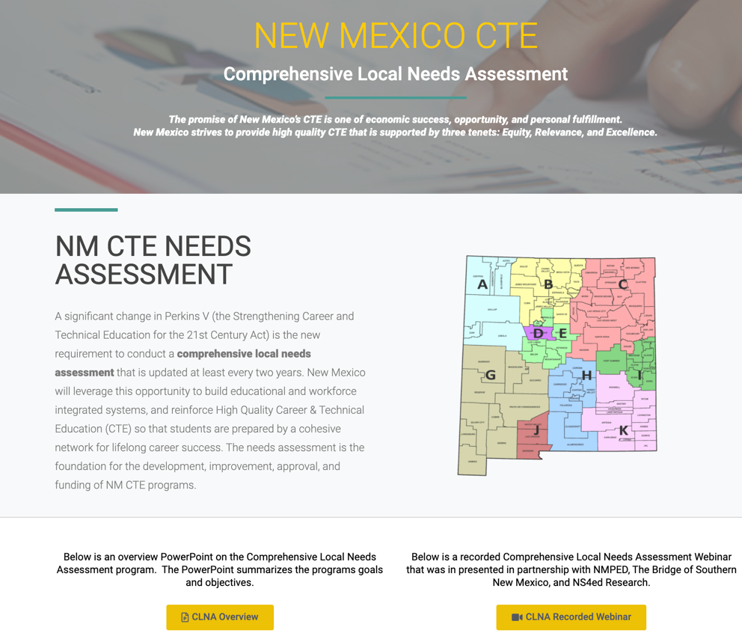

Figure 2: Regional Layout for NM CTE CLNA
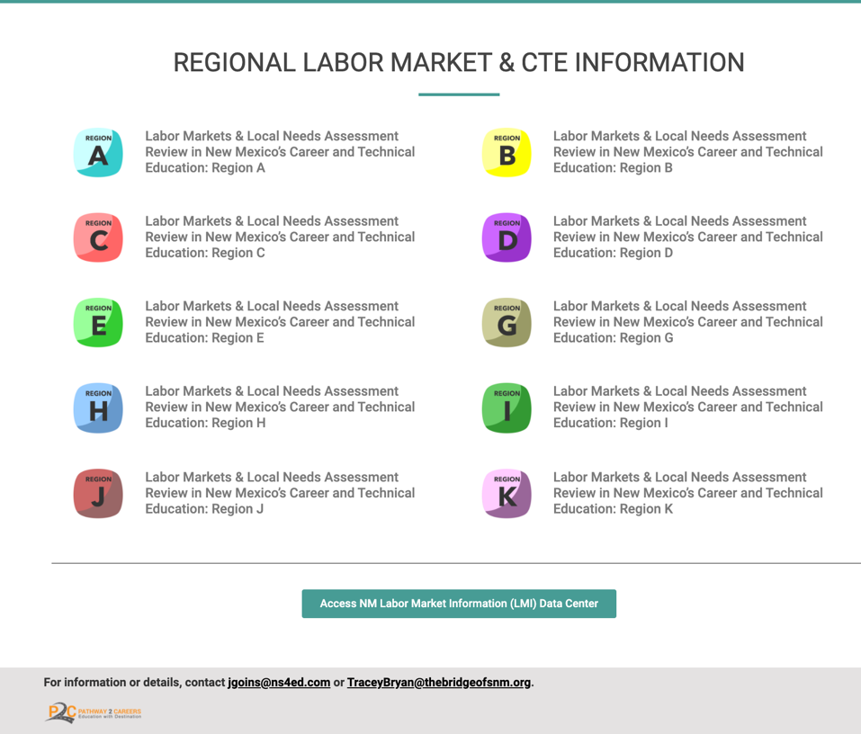
Aligning Regions

PED aligned each region as defined in Figure 3. The alignment process also aligned the regions to the local workforce councils, the geographic regional for high ed, and the economic development region.

Accompanying files will include a spreadsheet that outlines the consortia leads, the CTE Regions mapped to each School District, the Geographic Area of Responsibility, the county involved, the Local Workforce Board, the Economic Development Board, and the PED Consultant assigned to each region.

Figure 3: CTE Regions
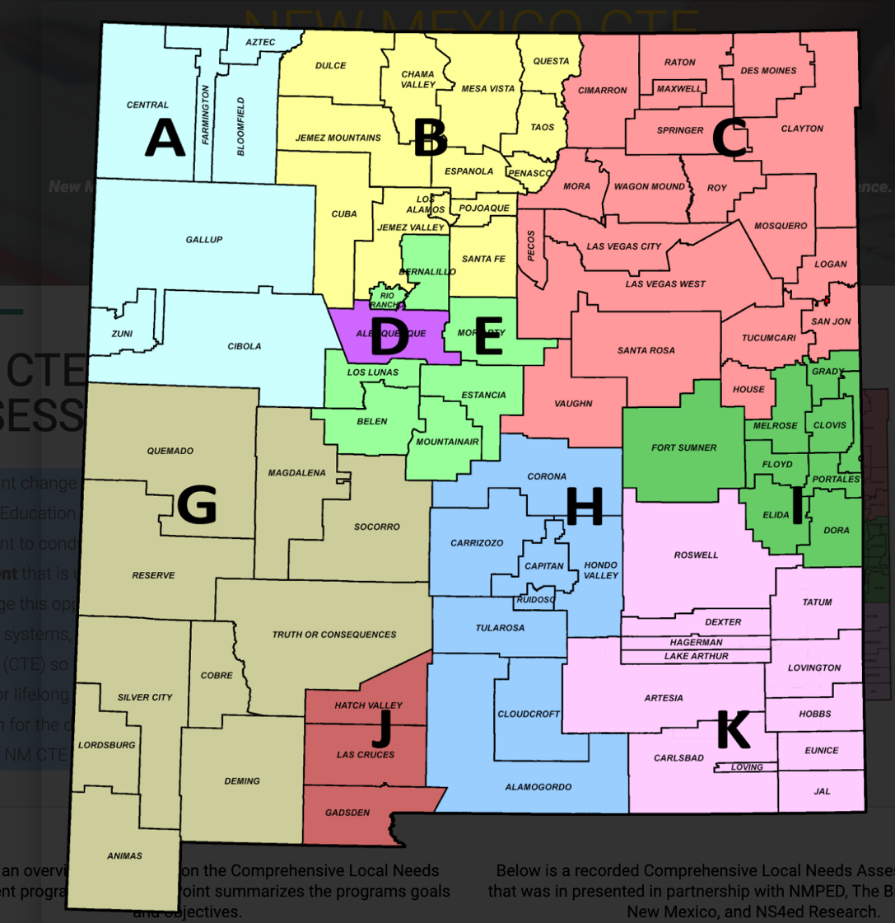

Data Collection

In order for each regional participant to have time to digest the opportunity and the potential as a consortium the following information was provided to review in advance:
- A labor market information (LMI) report was done for each region. Accompanying files include each of the 10 regional reports.
  - Key Findings for the regional report was broken down by:
    - The People
    - The Employers
    - The Jobs
  - Observations and Recommendations were provided in the LMI report
Additionally, each educational participant was asked to complete an online template using the NM CTE Needs Assessment Guidebook. The guidebook was used to prepare participants for the regional meetings. The templates helped educators identify potential local and regional partners and focus the regional discussion, analysis of data, and other evidence collected for each of the required CTE elements. The elements completed in the Guidebook were as follows:
- A: Identify Partners
- B: Local Needs Assessment
  - Priority Alignment
  - Size, Scope, and Quality
  - Student Performance
  - Access and Equity
  - Educator Training, Recruitment, and Retention
The data from the online guidebook was displayed on the technical resource center (Figure4) and a consolidation of the information was provided to each region ahead of the CLNA meeting. A summary of the pre-work is included in accompanying files.
Figure 4: Sample of Regional Prework
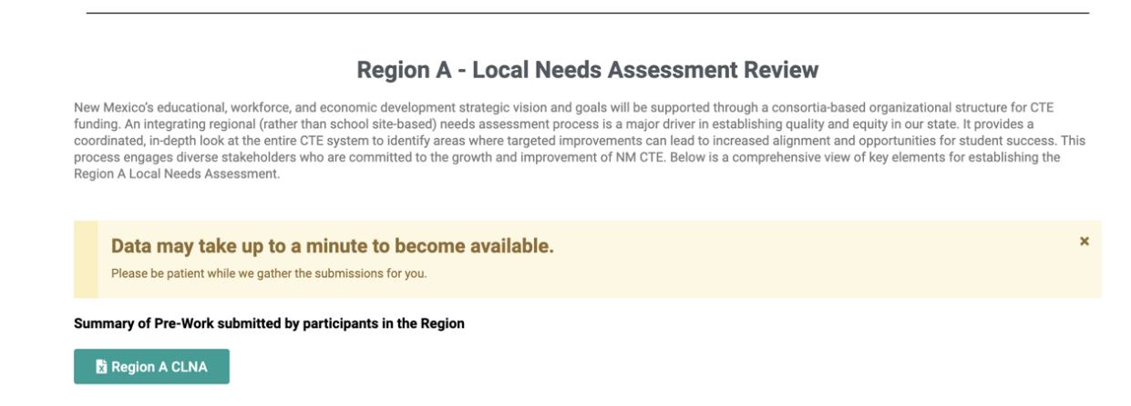
CLNA Participants

Invitations were sent out in each region for eight in-person CLNA meetings, and then for two virtual CLNA meetings forced upon the process by the response to COVID-19. The convenings were conducted from the end of February 2020 to mid-April 2020. Locations were chosen by the Consortia Leads, and space was made available primarily in community colleges or local chamber of commerce spaces. For the educators who attended, NMPED assigned one coach per region to help facilitate awareness, registration, and ultimately shepherding through the Perkins Application Process. Business and key community partners were invited through the Consortia Leads, which provided added emphasis to the importance of each meeting. The meetings were arranged in four-hour blocks, though most were completed within three hours.
A total of 331 educators and 448 business/community partners attended the CLNA meetings throughout the 10 regions. Excluding staff from PED, 779 people participated in the CLNA meetings statewide. The chart below provides a breakdown of each region’s participation. To reiterate, Regions B and D were conducted virtually, due to the COVID-19. In spite of the circumstances, the two regions had impressive attendance and completely consistent dialogue and conversation reflective of the other in-person meetings.
In regions A, B, E, G, H, I, J, and K, the number of Business/Community partners was greater than that of the educators, which allowed for multiple stakeholder engagement conversations to occur. Regions C and D were the only regions that had more education participants than that of the business/community partners, possibly showing a small bias toward the needs of education over that of the business and community partners.
Region | Educators | Business and Community Partners
A | 33 | 85
B* | 56 | 60
C | 35 | 13
D* | 56 | 45
E | 32 | 39
G | 29 | 54
H | 14 | 40
I | 19 | 28
J | 27 | 52
K | 30 | 32
TOTAL | 331 | 448
* CLNA process was conducted via Zoom Meeting due to Covid19

Summary of Findings and Recommendations

Focus Area 1: Vision for CTE

Focus Area 1 – Summary of Regional Decisions

By focusing on the characteristics of workforce talent needed in each of the 10 regions, each consortium was able to envision how CTE programs could become valuable partners in the cultivation of talent needed by current and future business and industry.
Themes emerged statewide about alignment and relevance to local industry and career awareness and exploration for students as being as important as instruction. Participants also realized the breadth of partnerships needed to ensure future success. They also voiced a need to consider how to best support small schools in offering high-quality programs.
Several regions began to understand that CTE programs could become drivers of regional identity and pride – “community.” Well-resourced and positioned, they could be key to retaining the next generation of workforce talent by preparing them for high-quality jobs in critical industries.
Consortia participants developed a clear understanding of the power of CTE programs as economic drivers for the long-term prosperity of their regions.

Vision Statements by Region
Region A
Region A’s Career and Technical Education programs promote regional pride though their distinct, diverse, well-qualified pools of talent relevant to the needs of current and future business and industry. Career and Technical Education graduates are well skilled, credentialed, and ready to drive the region’s economy.

Region B
Career and Technical Education in Region B provides relevant career exposure, preparation, and pathways for students aligned to meaningful careers in key industry sectors. CTE programs are agile and responsive to employers’ needs, equipping students with foundational skills for cross-industry application. It is flexible in design and delivery to provide the broadest possible access to high-quality programs throughout the region.

Region C
Career and Technical Education in Region C provides students and families focused exposure to career options and opportunities:
- Responsive to the needs of the region
- Generates credentials and training valued by employers in our target industry
- Is broadly accessible to all in the region

Region D
Career and Technical Education in Region D is seamlessly aligned and integrated in supporting career readiness for students as they navigate accessible pathways between K-12, college, and careers in relevant industry sectors. CTE is flexible and responsive to the evolving needs of both students and employers, generating talent with the right skills, attitudes, and credentials for long-term success.
Region E
Career and Technical Education in Region E is driven by collaboration with industry, students, and community and maximizes all of the resources in the region to achieve success. Talent in Region E is informed, educated, excited, and ready for careers here now, and in the future.

Region G
Career and Technical Education in Region G is aligned and responsive to the needs of business, industry, economic development, and entrepreneurial skills. It is mutually accountable and brings all partners together to grow and retain our local talent.

Region H
Career and Technical Education in Region H is an engaging partner to build a better future for the community.

Region I
Career and Technical Education in Region I generates well-informed, well-rounded talent. It brings together all of the partners, assets, and investments in the region to be aligned and responsive to the needs of industry and economic development. CTE provides both career exposure and training to create the best possible opportunities and outcomes for students and families.

Region J
Career and Technical Education in Region J provides broad exposure and optimal opportunity for students’ academic and economic success. Career and Technical Education creates a supportive community, aligned to the needs of students, businesses, industry, and economic development.
Region K
Region K’s Career Pathways breed innovation, opportunity, and progress. The Career and Technical Education system of the region creates a talent pipeline that drives and supports regional economic opportunities by engaging all stakeholders.

Characteristics of Local Talent

New Mexicans have a very clear and consistent picture of the characteristics that would ensure the next generation of workforce talent is ready for success. Across the regions, there was fairly consistent consensus along three categories: skills, attitudes, and workforce and life readiness.

Following are the most frequent responses for each.

Skills-based:
- Employability skills: problem-solving, critical thinking, self-directed with a strong work ethic, inquisitive and innovative, communication and interpersonal skills, teachable and committed to life-long learning, possessing a professional presence and confidence, and having the ability to pass a background check.
- Hard skills: having the right credentials and degrees; being able to demonstrate reading, math, and writing skills, technology competent, and having a diverse and flexible enough base of skills to respond to ever-changing industry and employer needs.
Attitudes:
- Reliable and dependable
- Motivated and passionate about the work
- Engaged and demonstrate initiative
- Adaptable to changing environments
- Culturally competent, responsive, and respectful of diversity
- Self-driven, responsible, and accountable
- Resilient
- Professional
- Environmentally conscious
Workforce and Life Readiness:
- Aware of career opportunities in their area
- Financially literate
- Hands-on experience through internships
Separately, the survey of New Mexico businesses echoed the some of the sentiments of the consortia conversations. Results showed the importance of candidates having both the right skills and real-world experience. Fully 97% of employers believed mastery of real-world skills was the best predictor of job success, as compared to only 3% for earned degrees or certificates.

Descriptions of Effective CTE Systems

By starting with a clear picture of the well-prepared, well-skilled talent of their region, each consortia was able to collectively describe the characteristics of the CTE system that could produce that kind of talent. Some regions recognized the potential and power of CTE to help forge a regional identity and pride – a force for stemming “brain drain” by connecting young people to the very best career opportunities in the region. Others honed-in on the idea of CTE as a “community” requiring strong collaboration to foster a sense of belonging across stakeholders: students, teachers, employers, and others. One region called it “a public priority.”

There was a clarion call statewide for closer alignment to the needs of business and industry, agility in responding to employer needs, and connecting work-based learning for real world experiences for students, with mentorship, internships, apprenticeships, and externships being specifically discussed. Robust CTE systems would be valued by employers if they were relevant and responsive to employers’ needs. Then, educators and students could benefit from active partnerships with business far beyond the traditional “advisory committee” approach.

Awareness of opportunity and exposure to career pathways beginning as early as elementary school would support more robust engagement with CTE programming over the long term. Participants recognized that investments in CTE needed to be greater, beyond the Perkins funding for their regions. Leveraging local non-profits, business partners, state funding, and other investments would better support high-quality programming throughout their regions.

Finally, each region recognized a need to think meaningfully about access. How could students in small, rural districts have access to the same programming as other larger districts? How could small districts have the faculty needed to deliver high-quality instruction? How could CTE respond to the diversity of students in the region while also instilling a diversity of skills that would support success in virtually any industry?

Some, not all, of the answers to these questions will require advocacy and flexibility from the NM PED and Secretary Ryan Stewart to support regions in realizing the visions for CTE in the state. Many consortia, now aware of the importance of CTE, saw a need for building awareness and demand for these programs. Fortunately, Perkins V provides the foundation for innovation and investment on which the state can build.

Following are some of the specific characteristics of CTE systems that best capture the most commonly shared responses among regions.

Business Relevance/Alignment
- Instruction must be relevant and agile to meeting the needs of business and responsive to the future needs of business and economic development, generating industry-valued credentials
- Instruction should combine rigor, expectations of employers, and create a culture between education and employers that models and mentors students in best practices
- Educational pathways must begin in middle school to high school to college to career
Career Awareness/Exposure
- Career pathways should begin with building awareness as early as elementary and middle school
- Seamless roadmaps through education providers to various careers in industries should be developed
- Families need to become more aware of the value of CTE for their students’ future economic wellbeing
- Focused on the future of work in the region
Skill Development
- CTE programs must focus on equipping students with the right skills:
  - Foundational skills (a solid base of knowledge and abilities that employers can build on)
  - Employability skills
  - Technical skills relevant to the particular industry
  - Cross-disciplinary skills that can be applied across industries and occupations
- Work-based learning and hands-on instruction were vital for engaging students and well-preparing them
- Skills are viewed as something to build on through stackable skills and credentials
Student Engagement
- Provides a “spark” of enthusiasm about becoming part of the regions’ workforce
- High quality instruction provided virtually to students in rural areas
- Considers the comprehensive needs of students from diverse backgrounds
Sustainability
- Leverages all of the assets of the region
- Intermediaries (external community-based organizations) have an important role to play in ensuring integration across programs and alignment to needs of employers
- Well-resourced and funded over time
- Well-promoted statewide

Focus Area 2: Industry Priorities
Focus Area 2 – Summary of Regional Decisions

The power of the Labor Market Analysis conducted for each region enabled consortia members to prioritize the best 2-4 industries for their regions.
Their decisions will lead to huge shifts in current funding to support industries key to diversifying New Mexico’s economy and create a new and powerful identify for the state’s Next Generation of CTE:
- Healthcare (8 regions)
- Skilled Trades (8 regions)
- Professional, Scientific, and Technical Services (4 regions)
- Intelligent Manufacturing (3 regions)
- Agriculture, Food, and Natural Resources to include Energy (3 regions)
- Information Technology (4 regions)
- Education (2 regions)
- Hospitality/Tourism (1 region)
There was significant crossover between prioritized industries and their applications to other industries. Using CTE pathways to prepare students for multiple local industry opportunities is supported by recommendations advanced in the Fordham Institute’s 2019 report, “How Aligned are Career and Technical Education to Local Labor Markets?” From the report:
“What we are suggesting – and what these results show – is that the country needs the local business, industrial, secondary and postsecondary education sectors to join hands. At the top of their to-do list should be better integration of what is taught in high school CTE programs with the skills, knowledge, and positions needed in local labor markets, both now and in the future – perhaps through more paid work apprenticeships and “sector strategies” that incorporate high school CTE into employer-driven partnerships that focus on regional, industry-specific needs.”

Following is a table that shows the alignment between the findings of the Labor Market Analysis and target industry sectors identified by each of the ten CTE regions.

Table X: Industry Recommendations and Decisions:
Region | Recommendations | CLNA Industry Targets | Selection Notes and Details
A | - Health Care  - Business Management  - Industrial Production Technology  - Skilled Construction Trades  - 21st Century Transportation | - Healthcare  - Intelligent Manufacturing  - IT | - IT-Artificial Intelligence  - IT-Big data and data analytics
B | - Health Care  - STEM  - Business Management  - Skilled Construction Trades  - Advanced Manufacturing | - Healthcare  - STEM/IT  - Skilled Construction Trades | - Trades specific to the green technologies and broadband infrastructure sectors  - Entrepreneurship skills should be a component of all pathways
C | - Education  - Business Management  - 21st Century Transportation  - Skilled Construction Trades  - Engineering Technologies | - Agriculture, Food and Natural Resources  - Skilled Construction Trades | - Agriculture Technology  - Precision Agriculture  - Non-Destructive Testing  - Integrated Control Systems
D | - Health Care  - Engineering Technologies  - Information Technology  - Skilled Construction Trades  - Business Management & Financial Operations | - STEM/IT  - Skilled Construction Trades  - Healthcare  - Hospitality | - Specifically in engineering applications  - Trades specific to architecture and manufacturing  - Each program should address management skills and CTE educator preparation
E | - STEM  - Business Management  - Skilled Construction Trades  - Education  - 21st Century Transportation | - Health Sciences  - Information Technology/STEM  - Manufacturing  - Skilled Construction Trades
G | - Architecture and Engineering  - Skilled Construction Trades  - 21st Century Transportation  - Mining and Natural Resources  - Advanced Manufacturing | - Healthcare  - Skilled Construction Trades  - Education | - Trades specific to the mining sector

Region | Recommendations | Council Selections | Selection Notes and Details
H | - Skilled Construction Trades  - Public Administration  - Health Care  - Architecture and Engineering  - Business Management | - Healthcare  - Skilled Construction Trades | - Trades specific to aerospace/defense and energy sectors
I | - Education  - 21st Century Transportation  - Installation, Maintenance & Repair  - Skilled Construction Trades  - Health Care | - Agriculture  - Manufacturing  - Technology | - Agriculture Manufacturing  - Agriculture Welding  - Agriculture Business Management  - Agriculture Trades  - Agriculture Logistics  - Technology in the Defense Industry  - Technology in the Gig Economy
J | - Health Care  - Business Management  - Information Technology  - Public Administration  - 21st Century Transportation | - Healthcare  - Professional, Scientific and Technical Services  - Skilled Construction Trades  - Education | - PST sectors specific to the aerospace, IT and Digital Media sectors  - Trades specific to agriculture, manufacturing and international trade
K | - Natural Resources and Mining  - Architecture and Engineering  - Industrial Production Technology  - Health Care  - 21st Century Transportation | - Skilled Construction Trades  - Healthcare | - Trades specific to the oil/gas, mining/extraction, energy and technical fields

Focus Area 3: Building Strong Partnerships
Focus Area 3 – Summary of Next Steps

Each of the CLNA meetings ended with the opportunity for school districts, charter schools, and community colleges to determine the role they sought to play in bringing their region’s vision to life.
The Public Education Department’s College and Career Readiness Bureau (CCRB) assigned team members to each region who would coordinate with the education partners and the Consortia Lead to determine Programs of Study best situated to prepare students for employment in target industries.
Consortia Leads submitted the decisions of their regions through the on-line portal created by the CCRB team, which opened the door for each of the educational partners to begin the Perkins application process.
The impact of the CLNA process to shape the trajectory of CTE investments across the state will ensure that these Federal investments in New Mexico’s future workforce achieve greatest possible returns for the economic wellbeing of students and the state.

The wisdom of the “consortia” approach to prioritizing CTE funding decisions laid out in the Perkins reauthorization sets the stage for not just shared decision making, but shared ownership of regional CTE programs. Each meeting cultivated new relationships that set the stage for a “community” approach to supporting a robust CTE system in their region.
Because of that sense of community and consensus in each meeting, commitments to continue the conversations and work toward goals extended beyond the education providers to include employers, local workforce boards, economic developers, and even non-profits.
Alignment of agreed-upon priority industries with the sector strategies being undertaken by local workforce boards also ensures maximizing the power of these federal investments to support a more comprehensive approach to talent development for each region’s target industries.
Following is the complete list of each region’s list of opportunities to pursue going forward.
Region A
Expanded Opportunities for Partnership and Sustainability Include:
- Explore opportunities for innovation in expanding the pipeline for generating the healthcare workforce by partnering with healthcare providers for expanding healthcare teacher force, clinical training sites, apprenticeship models

- Use this as an opportunity to “brand” the region
  - Include a communications campaign
- Leverage the location of Region A to create cross-state collaborations with neighboring states
- Seeking to become “the carbon capture capital of the world”
- Youth will innovate and help solve the problems of the region
- Career exploration for these careers needs to begin in middle school
  - Use Next Step plans to help guide students

Region B
Expanded Opportunities for Partnership and Sustainability Include:
- There is great value in delivering hands-on work-based learning opportunities for students throughout the region to support the creative way they think. Strong partnerships with employers like LANL and FLUTe can expand access to new avenues for work-based learning.
- There is a need and opportunity to leverage other funding sources to increase resources for STEM teachers building on efforts like the new STEM challenge
- There is an opportunity to elevate awareness with students and parents of the value of career certifications and two-year degrees to secure high-paying jobs in the region
- Smaller schools need flexibility in requirements for teacher credentials/endorsements to support the delivery of aligned programs throughout the region

Region C
Expanded Opportunities for Partnership and Sustainability Include:
- Eastern Workforce Board will partner in three ways:
- Leverage the One-Stop operators’ assets to provide professional development to teachers on how to train employability (“soft”) skills
- Integrate apprenticeship programs into CTE programs of study
- Focus WIOA resources to support increased workforce talent for healthcare occupations

- Other potential for pooled Initiatives include exploring:
  - Shared resources, including supplies and equipment that can be delivered through mobile assets
  - Professional development for CTE teachers and career counselors

Region D
Expanded Opportunities for Partnership and Sustainability Include:
- It’s critical that the region works to help instructors be ready to deliver instruction that instills the foundational, technical, cross-disciplinary, and employability skills.
- Work-based learning opportunities like internships and apprenticeships need to be intentionally woven into CTE pathways.
- There is an important role for intermediaries to play in the integration and alignment of the workforce system.

Region E
Expanded Opportunities for Partnership and Sustainability Include:
- There was also discussion about addressing the teacher shortage, and this will be discussed in follow-up conversations. The Central Workforce Board shares the focus on investments in local talent through Sector Strategies, which ensures CTE can build stronger collaboration with the Workforce Connections resources, as well.
- The strong focus on collaboration to maximize the power of CTE in the region will require ongoing relationships/conversations with business and industry to ensure talent pathways are well aligned to the relevant needs of employers in each industry.
- Looking for opportunities to leverage multiple funding streams for workforce development-related funding sources can help to ensure that CTE is well-funded.
- Elevating visibility for CTE among employers, as well as students and parents, will ensure maximum participation in CTE programs and let employers know where to find well-skilled talent.

Region G
Expanded Opportunities for Partnership and Sustainability Include:
- The Southwestern Area Workforce Development Board shares the focus on investments in local talent through Sector Strategies focused on Healthcare and Education, which creates an incredible opportunity for alignment with Workforce Connections resources.
- The strong focus on collaboration, alignment, and responsiveness to industry needs will create a comprehensive set of supports for workforce talent to be successful, as well as bringing other resources to support comprehensive talent development in the region.
- “We want to give our people the opportunity to stay. We want to raise them to be citizens and members of the community who can make things better. We want them to see it’s their responsibility to lift everyone else.”
- Underlying the cultivation of workforce talent is a need to support the cultivation of entrepreneurial skills to support other priorities for the region, including the outdoor recreation and tourism sector being advanced by Gov. Lujan Grisham.

Region H
Expanded Opportunities for Partnership and Sustainability Include:
- The Eastern Workforce Board shares the focus on investments in local talent through Sector Strategies, which included alignment on Agriculture and Healthcare. They also have a focus on Education, which was one of the industries that was brought up for investment.
- Meaningful expansion of the healthcare talent pool will require partnership and innovation with the healthcare providers to the region to expand the healthcare teaching force and clinical sites. This is an excellent opportunity to lead the state in innovative approaches to addressing the shortage of healthcare workers in the state.
- The Skilled Construction Trades have an important role to play in supporting the mission of Holloman Air Force Base. Facilities maintenance and careers with Holloman’s contractors provides access to some of the highest quality jobs in the region.
- Pursuing greater preparation of those in the building construction trades could also play a role in helping the region address the shortage/cost of housing.

Region I
Expanded Opportunities for Partnership and Sustainability Include:
- The United Way and its workforce-focused partnership will support for the development of the Information Technology and Manufacturing-focused goals to maximize the economic benefits to the region of these programs.
- Clovis and Portales EDC’s will stay engaged in leveraging employers in the region to expand work-based learning opportunities for students
- Tiffany Bretz with Southwest Cheese will participate in the consortia’s efforts to advance its goals
- Michael Stein will work with Juvenile services to engage at-risk youth in these career exploration and training programs
- The Eastern Workforce Board will work in partnership with the Region on their Sector Strategies, which included alignment on Agriculture, but also cover the two other industries brought up by the group:
- Allied Health
- Education

Region J
Expanded Opportunities for Partnership and Sustainability Include:
- The Southwestern Area Workforce Development Board shares the focus on investments in local talent through Sector Strategies focused on Healthcare and Education, which leverages greater resources into this “community-based” approach to CTE.
- The vision of creating a “community” to wrap-around our Career and Technical Education system is very powerful. Employers as active participants may require some work to remove the barriers that keep them from more directly outreaching to students with career exposure of relevant industries, as was pointed out in the Las Cruces Home Builders Association (LCHBA) example.
- Recruiting partners to help employers see the value of youth employment would help expand work-based learning opportunities.
- Prioritizing healthcare will require a broad partnership community-wide to address shortages of qualified instructors and limited clinical sites for healthcare professional certifications. We have the opportunity to widen the pipeline of talent but will need to address the structural barriers to growth.
- The LCHBA has raised $80,000 to support increasing opportunities for students to pursue careers in the skilled trades. They will be an important partner in this “community” approach.

Region K
Expanded Opportunities for Partnership and Sustainability Include:
- The Eastern Area Workforce Development Board shares the focus on investments in local talent through Sector Strategies focused on Healthcare, which will provide additional resources to support expansion of the talent pipeline. The Eastern Board is also focused on Education, which supports the identified gap in the teacher workforce.
- There is great opportunity to leverage existing efforts across the region to engage employers. Signature initiatives are already underway in Hobbs/Lea County and Roswell. The investment of CTE resources can support those on-going efforts.
- Employers in the region are eager to support efforts that go beyond meetings to taking action with specific goals and tactics.
- Small schools may benefit from Perkins Funding for the first time by pooling their efforts and working in partnership with the local REC’s.
- Terrific idea to expand on efforts underway to promote “signing”-type events for student who earn great jobs in the region.
- We need to tell our story better – opportunities that are here and why students have great opportunities to stay
- Regional independence – leverage those assets over which the region has control
- Promote local character

Recommendations

The approach of the New Mexico Public Education Department’s College and Career Readiness Bureau in the implementation of the Strengthening Career and Technical Education for the 21st Century (Perkins V) Act was groundbreaking and places the state at the forefront of CTE innovation. The concept of making CTE accountable to the community and relying on the perspectives of business and economic development to establish programming and policy priorities has the potential to make Career and Technical Education not just a byproduct of the state’s economic success, but a driver of it.
As New Mexico, under the leadership of Governor Lujan Grisham, strives to position the state for the demands of the 21st Century economy, the role of CTE within the talent development ecosystem becomes increasingly critical. Many of the industries on which the governor’s vision is built rely heavily on an appropriately skilled pipeline of talent for middle-skill occupations, and the potential of CTE to fill that pipeline is well-documented. However, the governor’s vision goes beyond middle-skill jobs in their current forms and aspires to the most technologically-advanced concepts on the frontiers of societal development. Aerospace. Sustainable agriculture. Digital Media. Bioscience. The opportunities for our citizens created by growth in these industries often will also require advanced levels of education. The innovative value proposition of this project is that an understanding of career pathways available in our most critical career fields expands a student’s perspective from “getting a job” to “embarking on a career.” The Comprehensive Local Needs Assessment meetings made clear that there are spectrums of careers within each field that range from entry-level to seasoned professional. CTE holds the promise of introducing students to a career pathway, not just a first job, and in doing so, it enables students to explore their passions, find their places, and enter the world of work in an informed and intentional way.
To move the CTE system to the forefront of the state’s strategic approach to the future, the momentum of this project must be sustained.
The Power of Partnership
A key to the success of this initiative was the role of economic development and business intermediary organizations as “conveners” of the regional conferences. These entities recruited participants and hosted the events. Their presence lent gravitas to the concept and highlighted NMPED’s commitment to making CTE a primary element of each region’s economic development efforts. While these organizations expressed desires not to become responsible for the management and distribution of Perkins funds, their enthusiastic commitment to supporting NMPED’s efforts was key to driving participation from the business and economic development communities.
The momentum created by the first year of this initiative has the potential to:
- Create communities of support for CTE in each region
- Integrate CTE into regional economic development strategies
- Encourage regional strategies and create regional resources that small districts could not sustain independently
- Build a culture of community-level collaboration and cooperation among the CTE system and regional business and development resources

Ongoing partnership and collaboration with these and even more industry and economic development partners is essential to sustaining optimal alignment between education and employment.
The initial round of work introduced the concept of industry prioritization and market-driven CTE strategy to new audiences. The positive response of business and community leaders in each region speaks to their willingness to support NMPED as it establishes and expands a new paradigm for a CTE system that contributes intentionally to the state’s economic future. A second round of this initiative will serve to further establish the concept by institutionalizing the Comprehensive Local Needs Assessment workgroups and opening new avenues of conversation and collaboration.
Are there industry associations that should become part of the ongoing conversation? How amenable are local employers to thinking differently about how they recruit and qualify talent? What must be done by educators to maximize the opportunities for students to have work-based learning experiences that provide exposure to industry along with instilling employability skills vital to workforce success? What real world challenges or projects could businesses task students with solving or completing that would be of benefit both educationally and to the employers? What is the role of this up-and-coming talent in helping employers better integrate technology into their operations to facilitate their eventual emergence into Industry 4.0?
The second year of the NMPED CLNA Project should follow on the successful work of the first year by leveraging existing momentum and new relationships. Priorities for the second year include:
- Leverage the momentum of the CLNA workgroups to keep business and economic development leaders engaged in each region
- Hone the input of the community leaders to provide guidance on making each CTE program as relevant as possible to the professional futures of our students
- Build a network of CTE champions in each community, who are willing to contribute to the success of CTE programming in each region

The second year of the project should accomplish these objectives by profiling New Mexico’s CTE programs, mapping them to the most critical occupations and industries in each region and executing a second round of CLNA Conferences in each CTE Region across the state. The inputs from business, community and economic development leaders in each CLNA workgroup will be synthesized into practical recommendations for each CTE Region.
The robust nature of what could be the Next Generation of CTE in New Mexico will only emerge as the cross-sector conversations that began in the regional meetings continue. The state’s industry associations, local business leaders, chambers of commerce, and public and private economic developers must continue to inform educators, partner on program design and implementation, and cultivate new ways for CTE students to become active participants in work and economic growth in the region. Quantifying the return on investment for business actively participating in their talent pipelines must be calculated and communicated.

Realignment and/or Segmentation of Regions
In some regions, optimization of that education/industry alignment will require realignment or segmentation of regional designations. For example, Region K has a dynamic and robust partnership with the Oil & Gas industry and had already done an enormous amount of listening with businesses to inform the development of a CTE-focused high school funded by Hobbs, two private foundations, industry partners, and others. This is a great community-specific effort that Perkins funding will be helpful in sustaining. However, the Eddy County districts of Carlsbad and Artesia were not connected to this effort and readily acknowledge that partnership in the past hasn’t been easy.
Another example is the vast, rural geography of Region C. There is a long-standing economic development entity that has done some good research work, but penetration of efforts seems disparate across counties.
Yet, other regions, like Regions A and J and the eastern part of Region K have the opportunity to maximize the impact of their efforts by pursuing cross-border collaborations with neighboring states with similarly aligned economic industry drivers.
Seamless Alignment of High School and College CTE Programs
The US Chamber of Commerce sits at the forefront of this type of collaboration through their Talent Pipeline Management (TPM) effort. The Bridge of Southern New Mexico’s work, while not an official TPM project, is viewed by the Chamber as one of the top 35 projects in the country and is a member of their Business Leads Elite Cohort. Replication of the work to map holistic workforce pathways locally and regionally will support seamless alignment between high school and post-secondary CTE programs to provide progressive development of the right skills and credentials needed by industry employers while accelerating students’ ability to complete programs and earn industry-valued credentials and degrees.
Career and Technical Education as Expectation
Once the CTE “ecosystem” is aligned and working at full collaboration with one another, the next step is invite more students, youth, young adults, and low-skilled workers into it. Every region discussed the need to increase awareness of industry opportunities and the value of CTE courses. CTE can be the foundation of holistic workforce pathways – if clearly understood.
At a recent US Chamber event hosted for members of their Business Leads Elite Cohort, the systems change model championed by the Prosci, a global change management leader, provided the framework for facilitating systems change – be it for a global enterprise or a community. This model could help facilitate the Next Generation of CTE in New Mexico. Prosci’s ADKAR® model includes:
- Awareness of the Need for Change
- Desire to Support the Change
- Knowledge of How to Change
- Ability to Demonstrate Skills and Behaviors
- Reinforcement to Make Things Stick

The College and Career Readiness Bureau may benefit from reaching out to Prosci to learn more about their model, their trainings for groups, and consideration of offering professional development opportunities for the state’s CTE educators at an upcoming gathering.
Additionally, the Next Generation of CTE in New Mexico needs ambassadors – those who have lived the power of CTE and can bring life and story to encourage participation across stakeholder groups: students, businesses, parents, and educators. The NM Public Education Department could develop and deploy a statewide communications campaign that builds awareness, fosters exploration, and encourages participation in the pathways prioritized across the state. Awareness of opportunity will build demand and reframe the decades old stereotype of “vocational” education that was intended for non-college-going students. Every student in the state should be a CTE student at some point in their academic career. Knowing the power of CTE participation and concentration of courses in increasing likelihood to graduate makes this an imperative for a state that annually logs the lowest graduation rates in the county.
Increasing Work-Based Learning
Apprenticeships offer a new tool in the educators’ toolbox for cultivating more opportunities for work-based learning for students that lead directly to employability. Each of the four workforce boards now has an Apprenticeship Coordinator. The Coordinator’s job is to work with local employers in target industries to cultivate apprenticeship opportunities in what have been non-traditional industries for apprenticeships. The high prioritization of apprenticeships within Healthcare and Professional, Scientific, and Technical Services, along with Information Technology would rapidly accelerate employers’ ability to recruit future talent by becoming active participants in training them.
It will be important for CTE systems to intentionally partner with their local workforce boards to intentionally integrate apprenticeships into their CTE pathways into both high school and community college pathways.
Conclusion
The New Mexico Public Education Department should commit all resources necessary to ensuring this initiative is not a one-time exercise. The willingness of New Mexico communities to commit time, energy and expertise to this project has been inspirational, and it is the hope of this project team that the momentum created here will fuel an expanded and extended version of this project that will carry the state’s CTE system to new levels of relevance, value and success in the 21st Century Labor Market.

Appendix

Appendix One
Table X: Population Change 2010-2019:
Region | County | Total | Under 10 Years |  | 10-19 Years |  | Over 65 Years
A | San Juan | -5,000 | -13% | -9% |  | +30%
 | Cibola | -620
 | McKinley | +620
B | Rio Arriba | -1,200 | -12% | -2% |  | +57%
 | Los Alamos | +1,100
 | Taos | 0
 | Sandoval | +11,800
 | Santa Fe | +7,000
C | Colfax | -1,600 | -19% | -19% |  | +24%
 | Union | -400
 | Quay | -750
 | Mora | -400
 | Harding | 0
 | San Miguel | -1,800
 | Guadalupe | -400
D | Bernalillo | +14,800 | -12% |  | -3% |  | +36%
E | Sandoval | +12,700 | -12% | -3% |  | +44%
 | Bernalillo | +14,800
 | Valencia | -341
 | Torrance | -808
G | Grant | -2,000 | -10% | -13% |  | +16%
 | Luna | -1,100
 | Socorro | -1,000
 | Catron | -170
 | Sierra | -1100

Region | County |  | Total |  | Under 10 Years |  | 10-19 Years |  | Over 65 Years
H | Otero | +2400 |  | -4 |  | -5 |  | +21
 | Lincoln | -900
I | Curry | 474 |  | -9 |  | -8 |  | +12
 | Roosevelt | -1,280
 | De Baca | -250
J | Luna | -1,100 |  | -6 |  | -4 |  | +27
 | Dona Ana | +6,400
K | Eddy | +4,000 |  | -1 |  | 7 |  | +12
 | Chaves | -1000
 | Lea | +5,000

Appendix Two
Table X: Educational Attainment:
Region | Percentage with a Bachelor’s Degree or Higher | Percentage with Some College Experience, but No Degree
A | 13% | 58%
B | 29% | 51%
C | 19% | 58%
D | 33% | 47%
E | 30% | 49%
G | 20% | 51%
H | 21% | 54%
I | 20% | 53%
J | 25% | 46%
K | 15% | 54%

Appendix Three
Deliverables
A full set of deliverables created during this project are being shared through a Google drive that can be found here: https://drive.google.com/drive/folders/18AVWNourkQTJUuZdMeiKWK5_DrMtsWov?usp=sharing

Deliverables included:
- Consortia Leads Webinar Slides
- Educator Webinar Slides
- CLNA Alignment Spreadsheet
- CLNA Regional Needs Assessments Prepared by Educators
- CLNA Attendee Lists
- Labor Market Analysis by Region
- CLNA Presentations by Region

References

Accenture Manufacturing Institute. (2014). Out of inventory: Skills shortage threatens growth for US manufacutring. Retrieved from http://www.themanufacturinginstitute.org/Research/Skills-and-Training-Study/~/media/70965D0C4A944329894C96E0316DF336.ashx
Adecco Group. (2013). State of the economy and employment 2013. Retrieved from https://www.adeccousa.com/about-adecco-staffing/newsroom/press-releases/state-of-the-economy-and-employment-2013/
Association of American Colleges and Universities. (2018). Fulfilling the American dream : Liberal education and the future of work. Retrieved from https://www.aacu.org/sites/default/files/files/LEAP/2018EmployerResearchReport.pdf
Bloomberg Next. (2018). Building tomorrow’s talent: Collaboration can close emerging skills gap. Retrieved from https://www.bna.com/uploadedFiles/BNA_V2/Micro_Sites/2018/Future_of_Work/Workday Bloomberg Build-Tomorrow-Talent_FINAL.pdf
Business Roundtable. (2017). How CEOs are helping close America’s skills gap. Retrieved from https://s3.amazonaws.com/brt.org/BRT-SkillsGap201711012017(1).pdf
Carnevale, A., & Cheah, B. (2018). Five rules of the college and career game. Georgetown Center on Education and the Workforce. Retrieved from https://1gyhoq479ufd3yna29x7ubjn-wpengine.netdna-ssl.com/wp-content/uploads/Fiverules.pdf
Carnevale, A., Fasules, M., Huie, S. B., & Troutman, D. (2017). Major matters most: The economic value of bachelor’s degrees from the University of Texas system. Georgetown Center on Education and the Workforce. Retrieved from https://1gyhoq479ufd3yna29x7ubjn-wpengine.netdna-ssl.com/wp-content/uploads/UT-System.pdf
Carnevale, A., Smith, N., & Strohl, J. (2010). Help wanted: Projections of jobs and education requirements through 2018. Georgetown Center on Education and the Workforce. Retrieved from https://1gyhoq479ufd3yna29x7ubjn-wpengine.netdna-ssl.com/wp-content/uploads/2014/12/fullreport.pdf
Carnevale, A., Smith, N., & Strohl, J. (2013). Recovery: Job growth and education requirements through 2020. Georgetown Center on Education and the Workforce. Retrieved from https://cew.georgetown.edu/wp-content/uploads/2014/11/Recovery2020.FR_.Web_.pdf
Carnevale, A., Strohl, J., Cheah, B., & Ridley, N. (2017). Good jobs that pay without a BA. Georgetown Center on Education and the Workforce. Retrieved from https://goodjobsdata.org/wp-content/uploads/Good-Jobs-wo-BA.pdf
Carnevale, A., Strohl, J., Ridley, N., & Gulish, A. (2018). Three educational pathways to good jobs. Georgetown Center on Education and the Workforce. Retrieved from https://1gyhoq479ufd3yna29x7ubjn-wpengine.netdna-ssl.com/wp-content/uploads/3ways-FR.pdf
Cohn, S. (2017). Here’s what the June unemployment rate is not telling you about job losses. CNBC. Retrieved from https://www.cnbc.com/2017/07/07/heres-what-the-unemployment-rate-is-not-telling-you-about-job-losses.html
Cooper, P. (2017, July 13). New York fed highlights underemployment among college graduates. Forbes. Retrieved from https://www.forbes.com/sites/prestoncooper2/2017/07/13/new-york-fed-highlights-underemployment-among-college-graduates/#45d30bb740d8
Council of Economic Advisors. (2018). Addressing America’s reskilling challenge. Retrieved from https://www.whitehouse.gov/wp-content/uploads/2018/07/Addressing-Americas-Reskilling-Challenge.pdf
Crowe, M. (2019). Unprepared and unaware: Upskilling the workforce for a decade of uncertainty. Southern Regional Education Board. Retrieved from https://www.sreb.org/sites/main/files/file-attachments/2019_adultattain_webversion.pdf
Deegan, B. J., & Martin, N. (2018). Demand driven education: Merging work & learning to develop the human skills that matter. Pearson. Retrieved from https://www.pearson.com/content/dam/one-dot-com/one-dot-com/global/Files/about-pearson/innovation/open-ideas/DDE_Pearson_Report_3.pdf
Dunkelberg, W. C., & Wade, H. (2010). NFIB small business economic trends. National Federation of Independent Business. Retrieved from https://www.nfib.com/assets/SBET-Aug-2018.pdf
Estes, Austin. “Home: Advance CTE.” Federal Policy Strengthening Career and Technical Education for the 21st Century Act, 13 July 2018, careertech.org/.
Frueh, S. (2017). United States’ skilled technical workforce is inadequate to compete in coming decades; Actions needed to improve education, training, and lifelong learning of workers. The National Academies of Sciences, Engineering, and Medicine. Retrieved from http://www8.nationalacademies.org/onpinews/newsitem.aspx?RecordID=23472
Gonzalez, G., Robson, S., Phillips, A., Hunter, G., & Ortiz, D. (2015). Energy-sector workforce development in West Virginia. RAND Corporation. Retrieved from https://www.rand.org/content/dam/rand/pubs/research_reports/RR800/RR812/RAND_RR812.pdf
Handel, M. J. (2016). What do people do at work? A profile of U.S. jobs from the survey of workplace skills, technology, and management practices (STAMP). Journal for Labour Market Research, 49(2), 177–197. https://doi.org/10.1007/s12651-016-0213-1
Hanover Research. (2014). Best practices in soft skills assessment. Retrieved from https://www.gssaweb.org/wp-content/uploads/2015/04/Best-Practices-in-Soft-Skills-Assessment-1.pdf
John, D. D., Chen, Y., Navaee, S., & Gao, W. (2018). Board 57: STEM education from the industry practitioners’ perspective. Paper presented at 2018 ASEE Annual Conference & Exposition. Salt Lake City, Utah. Retrieved from https://peer.asee.org/30062
ManpowerGroup. (2018). Solving the talent shortage. Retrieved from https://go.manpowergroup.com/talent-shortage-2018#thereport

Manyika, J., Lund, S., Chui, M., Bughin, J., Woetzel, J., Batra, P., … Sanghvi, S. (2017). Jobs lost, jobs gained: Workforce transitions in a time of automation. McKinsey Global Institute. Retrieved from https://www.mckinsey.com/mgi/overview/2017-in-review/automation-and-the-future-of-work/jobs-lost-jobs-gained-workforce-transitions-in-a-time-of-automation
Memmot, M. (2011, June 15). 2 million “open jobs”? Yes, but U.S. has a skills mismatch. Retrieved from https://www.npr.org/sections/thetwo-way/2011/06/15/137203549/two-million-open-jobs-yes-but-u-s-has-a-skills-mismatch
Muro, M., Maxim, R., & Whiton, J. (2019). Automation and artificial intelligence: How machines are affecting people and places. Metropolitan Policy Program at Brookings. Retrieved from https://www.brookings.edu/wp-content/uploads/2019/01/2019.01_BrookingsMetro_Automation-AI_Report_Muro-Maxim-Whiton-FINAL-version.pdf
Northwest Evaluation Association. (2018). Assessing soft skills: Are we preparing students for successful futures? Retrieved from https://www.nwea.org/content/uploads/2018/08/NWEA_Gallup-Report_August-2018.pdf
Sawchuk, S. (2018, September 25). How to make reading relevant: Bring job-specific texts into class. Education Week. Retrieved from https://www.edweek.org/ew/articles/2018/09/26/how-to-make-reading-relevant-bring-job-specific.html
Shearer, C., & Shah, I. (2018). Opportunity industries: Exploring the industries that concentrate good and promising jobs in metropolitan America. Brooking Policy Program.
Society for Human Resources Management. (2008). Workforce readiness and the new essential skills. Retrieved from https://www.shrm.org/hr-today/trends-and-forecasting/labor-market-and-economic-data/Documents/08-0175WV_FINAL.pdf
Templeton, G. (2018). Survival in tomorrow’s business world means closing the skills gap. Forbes. Retrieved from https://www.forbes.com/sites/adp/2018/03/16/survival-in-tomorrows-business-world-means-closing-the-skills-gap/#8be1a047a6b7
Udemy. (2018). 2018 skills gap report. Retrieved from https://research.udemy.com/wp-content/uploads/2018/11/FINAL-Udemy_2018_Skills_Gap_Report_Complete-1.pdf
US Chamber of Commerce Foundation. (2017). Bridging the soft skills gap. Retrieved from https://www.uschamberfoundation.org/sites/default/files/Closing the Soft Skills Gap.pdf
Weise, M. R., Hanson, A. R., Sentz, R., & Saleh, Y. (2018). Human+ skills for the future of work. Strada Institute for the Future of Work. Retrieved from https://www.economicmodeling.com/wp-content/uploads/2018/11/Robot-Ready_ExSumSingles_FA1.pdf
Weissmann, J. (2012, April 23). 53% of recent college grads are jobless or underemployed—how? The Atlantic. Retrieved from https://www.theatlantic.com/business/archive/2012/04/53-of-recent-college-grads-are-jobless-or-underemployed-how/256237/
World Economic Forum. (2018). The future of jobs report 2018. Retrieved from http://www3.weforum.org/docs/WEF_Future_of_Jobs_2018.pdf

